Your direct member benefits from the Michigan Soybean Association include:
NEW TO MSA MEMBERS: A $300 Specialty soybean seed certificate (will require a minimum order of 30 units) with a 3-year or Lifetime membership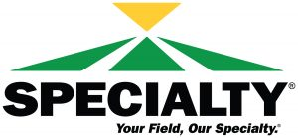
- Member benefit with AGI Sure Track Farms
- Through Auto-Owners Insurance/Cedar River Insurance Agency, an offer of premium discounts up to 10% on select policies is available.
- *Scholarship opportunities for your children and grandchildren
- *Preferred pricing on the purchase or lease of most new GM, Chrysler, Dodge or Jeep vehicles
- *Cabela’s gift card purchase discount
- *Discounted registration to the Commodity Classic
*More member information on these benefits at www.soygrowers.com.
3-year or Lifetime Memberships Receive:
- $50 soybean seed certificate good for Renk Seed
- 2-$25 Soy Biodiesel certificates OR 2-$25 Soybean Meal Bucks certificates
The MOST IMPORTANT MSA membership benefit: Having a voice in Lansing and Washington, D.C.!

